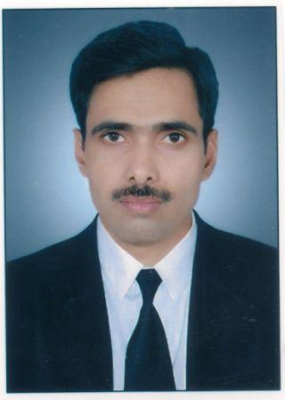

**Dr. Anil Kumar**

**Assistant Professor**

.

**Teaching and Research Experience:**

9 Years of Teaching and Research Experience**.**

**Research Interest**:

* Materials Science-Condensed Matter (Soft material- liquid crystals) and thin films fabrication and Characterizations.

**Distinguished and Notable Awards**

* Member of Board of Studies
* Ex-Member of Executive Council

**Work Experience**

* **Assistant Professor**, Department of Physics and Electronics
* **Deputy Coordinator**: Ph.D. Admission Test-2019
* **Deputy Coordinator**: Residential Common Admission Test-2018 and 2019.
* Assistant Dean Student Welfare
* **Ex-Assistant Proctor**
* Worked as Assistant Centre Superintendent of Examination in Semester and Annual Examinations.

**Citation / h / i-10 indexes**:

**Citation Index: 32**

**h-index : 04**

**i10-index : 02**

**No. of research papers in journals:09**

**Participation in Conference/Seminars: 04**